


Scope and Storyboard for
Supervision Of Client Communication

Amandeep Randhawa, Manchester

Table of Contents

1. Document Revision History 2
1.1. Document Location 2
1.2. Revision History 2
1.3. Reviewed by 2
1.4. Approvals (please complete ‘name’ column on first draft) 2
1.5. Distribution 2
2. Summary of Scope 3
3. Screen design 4
4. Workflow 10
5. Navigation 17
5.1. Where will the Flow be launched from 17
5.2. Where should the Flow return to 17
6. SQL Tables 17
6.1. Table 17
6.2. Lookup 17
6.3. Field 17
7. Stored Procedures 18
7.1. Fetch 18
7.2. Save 18
8. Document Templates 19
9. Javascript 19

Document Revision History

Document Location
Full File Path
/tmp/lo/0000.doc

Revision History
Version Number | Revision Date | Summary of Changes | Changes marked | Author
01 | 14/07/2011 | First issue | No | AKR
02 | 25/07/2011 | GQL/AKR amendments | No | GQL
03 | 01/08/2011 | LMW amendments | Yes | LMW
04 | 02/08/2011 | AKR Changes | Yes | AKR

Reviewed by
Name | Signature | Title | Date of Issue | Version
Gareth Levingston |  | Senior Business Analyst
Lisa Williams |  | Project Manager | 25/07/2011 | 02

Approvals (please complete ‘name’ column on first draft)
Name | Signature or  Date of Approval Email | Title | Date of Issue | Version
Lisa Williams | 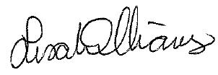 | IT Development & Projects Manager | 09/08/2011 | 04

Distribution
Name | Title | Date of Issue | Version

Summary of Scope

This scope describes the provisions that need to be made within the FloCase system to provide the necessary levels of supervision and client communication required for each FloCase Document created. To accommodate these supervision levels the scope also outlines the changes that are required to be made within existing FloCase screens.

Task Supervision Process

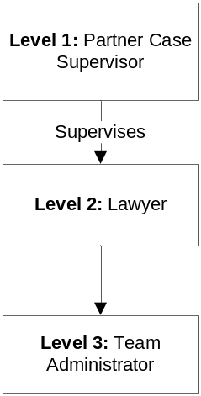

(For Information Purposes only)

Notes:

- FloCase needs to be able to mark documents which require Supervisor Approval.
All of these marked documents must be assigned to the supervisor on the case for approval whether produced ad hoc or within a flow.

- If the Supervisor rejects at the approval process, the task is sent back to the Lawyer to correct. When the Lawyer completes this task, the task is re-assigned to the Supervisor until approved.

- If the Supervisor approves at the approval process, the task is assigned to the Team Administrator to print out the relevant document.

- If the Supervisor runs a task on behalf of a Lawyer, FloCase should still treat the task as being run by the Lawyer (i.e. the task still goes to the stated supervisor on the case to approve). The Supervisor can then pass this on manually to whoever may need to approve the document.

- Any team member within the same access/security level can run one another’s tasks.

- Any team member with the same access/security level can re-assign their tasks to an individual.

Screen design

3.1 Amend ‘Template Maintenance’ Screen (Template mapping Administration section)

A new checkbox ‘Requires Supervision?’ is required within the ‘Template Maintenance’ screen as outlined in the diagram below. By default all documents produced will not require supervision unless the checkbox is checked.

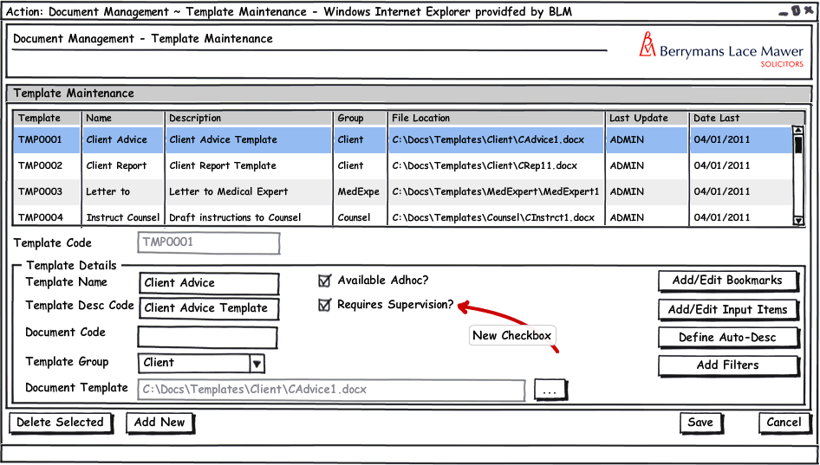

The input for the new field Requires Supervision should be stored within the existing dmsTemplates table in a new column called dmsTemplates_ReqSup of data type bit defaulted to 0.

Amendments required to the following stored procedures to accommodate the new field Requires Supervision as detailed below:
- dmsTemplates_Fetch – New field dmsTemplates_ReqSup residing in dmsTemplates should be added to the return values
- dmsTemplates_Save – New field dmsTemplates_ReqSup residing in dmsTemplates should be added to both the inputs and the save mechanism within the stored procedure

  - Amend Pending tasks (Column list)

A new column ‘Date Assigned’ is required within task lists to display when a Task was assigned to the relevant person. This is in order to help prioritise workload. In order to display this information the below amendments are required, to enable these amendments the following data structure changes are required:

The input for the new field Date Assigned should be stored within the existing AppTask table in a new column called AppTask_DateModified of data type smalldatetime defaulted to today’s date.

Amendments required to the following stored procedures to accommodate the new field Requires Supervision as detailed below:
- AppTask_CreatePending – New field AppTask_DateModified residing in AppTask should be added to the save mechanism within the stored procedure defaulted to the date and time of execution (i.e. GETDATE())
- Apptask Reschedule – New field AppTask_DateModified residing in AppTask should be added to the save mechanism within the stored procedure defaulted to the date and time of execution (i.e. GETDATE())
- AppTaskConsole_Fetch – New field AppTask_DateModified residing in AppTask should be added to the return values
- AppTask_Fetch – New field AppTask_DateModified residing in AppTask should be added to the return values

3.2.1 Case Actions Tab –‘Schedule a Task’ (Reminder screen)

- A new field ‘Last Modified Date’ is required on the Reminder – Schedule a task screen above the Start Date.
- The field should default to today’s date
- This field should be hidden (invisible on the user front end)
- The field should display the date on which the task was last modified.

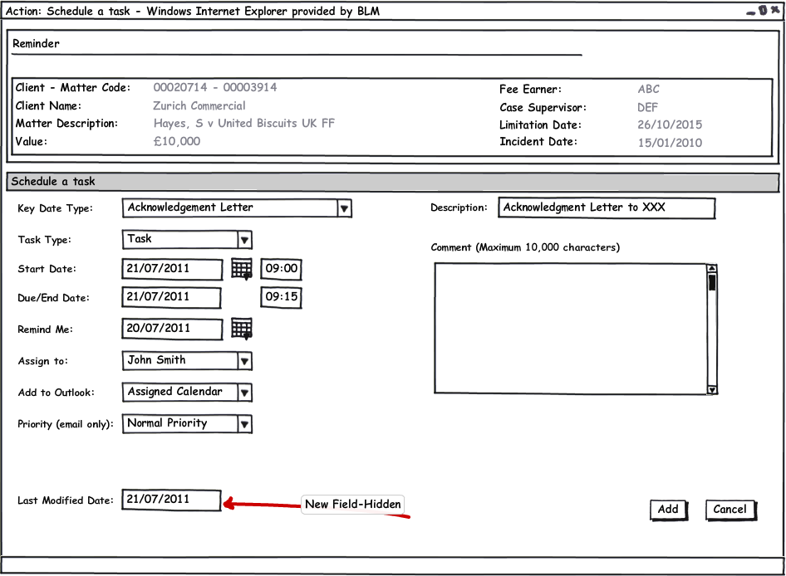

3.2.2 Outlook Landing Page – Pending Tasks

- This screen requires a new field labelled ‘Date Assigned’ – this will be the Last Modified Date from the Case Actions Tab –‘Schedule a Task’ (Reminder screen) as mentioned above.
- The field will need to be displayed before the ‘Due Date’ column.
- An alteration to AppTaskConsole_Fetch will add a new field to the return set called AppTask_DateModified this field should be added to the grid shown below to provide ‘Date Assigned’

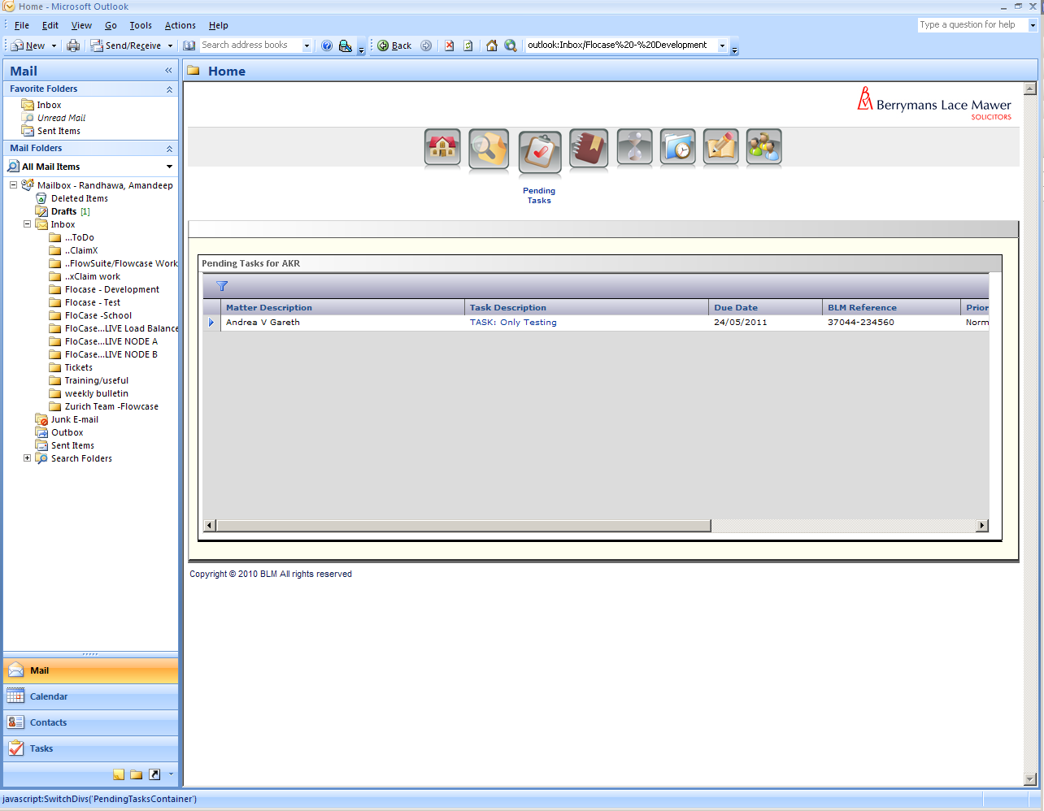
New Field: Date Assigned

3.2.3 Outlook Landing Page –Team Pending Tasks

- This screen has the same requirements as above - a new field ‘Date Assigned’

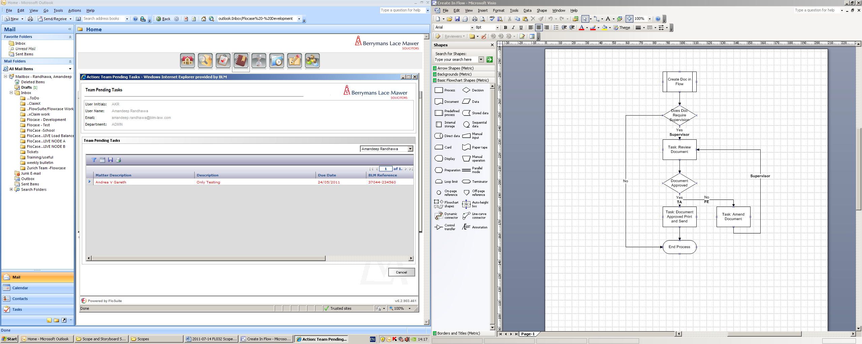
New Field: Date Assigned

3.2.4 Pending Tasks Tab (matter/case level)

- This screen has the same requirements as above - a new field with the label ‘Date Assigned’
- An alteration to AppTask_Fetch will add a new field to the return set called AppTask_DateModified this field should be added to the grid shown below to provide ‘Date Assigned’

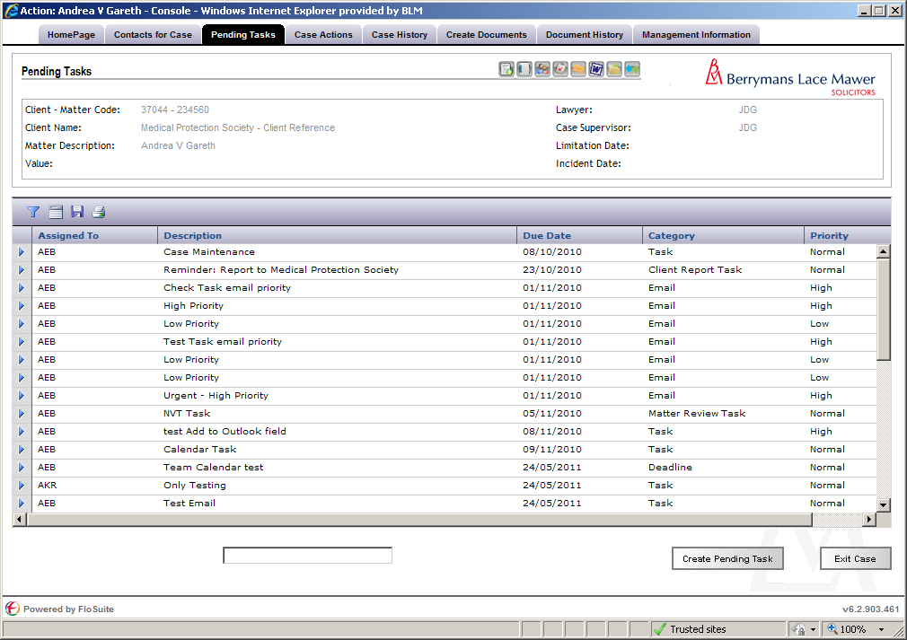
New Field: Date Assigned

3.3 New ‘Task: Review Document’ screen Layout

- When a task is assigned to a supervisor to review and approve a document, they should be presented with the new screen ‘Review Document’ shown below:
- When a document is created ad hoc, the system should check to see if Supervision is required on the document. If the document does require supervision the ‘Review Document’ Task should be scheduled.

    - For Tasks assigned to Supervisors

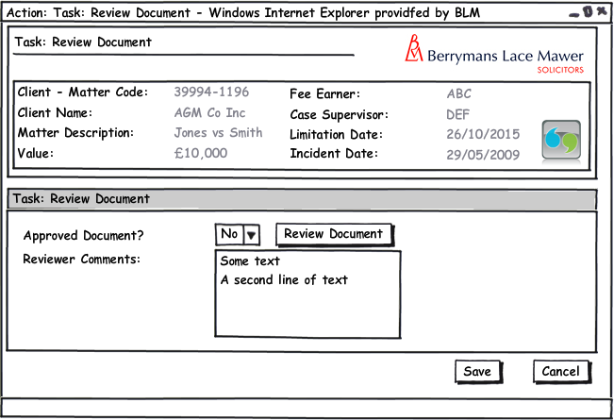

The screen includes the following fields:

Task: Review Document: Label
Approved Document? Combo box having the following options (Populated using LTMM_LookupCodes_Fetch with @LookupTypeCode = 'YesNo', @BlankRow = 1):
- Yes
- No
(The user selects Yes if they have approved the document and No if they have not approved the document)
Review Document: Button – retrieves/ opens the latest version of the relevant document to review
Reviewer Comments: Text Box (The user can use this field to write any comments regarding the document). This field is non-mandatory.
Save: Will schedule the task ‘Amend Document’ for the Lawyer if not approved or schedule a pending task to the Team Administrator ‘<DocumentName> Approved - Print and Send’ if approved in order to print. Both tasks should be scheduled immediately for the same day.
Cancel: Returns the user back to their Pending Task list.

To enable these amendments the following data structure changes are required:

The input for the new field Approve Document should be stored within the existing AppTaskDocumentVersion table in a new column called AppTaskDocumentVersion_ Approved of data type nvarchar(255).
The input for the new field Review Comments should be stored within the existing AppTaskDocumentVersion table in a new column called AppTaskDocumentVersion_ReviewComments of data type nvarchar(max).

Amendments required to the following stored procedures to accommodate the new field Requires Supervision as detailed below:
- AppTaskDocumentVersion_Fetch – New fields AppTaskDocumentVersion_ReviewComments and AppTaskDocumentVersion_ Approved residing in AppTaskDocumentVersion should be added to the return values
- AppTaskDocument_IncVersion – New fields AppTaskDocumentVersion_ReviewComments and AppTaskDocumentVersion_ Approved residing in AppTaskDocumentVersion should be added to the save mechanism within the stored procedure. AppTaskDocumentVersion_ Approved should be defaulted to No if the document requires supervision and no value has been passed for this field

Note: To fully encapsulate this functionality further changes to the data structure may be required that are not obvious at the point of scope creation

    - For Tasks assigned to Lawyers

A task ‘Amend Document’ is assigned to a Lawyer to amend a document when a document has not been approved by their supervisor as presented in the below screen:

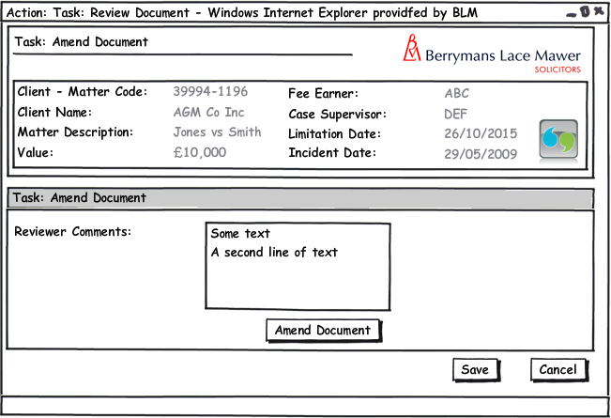

The screen includes the following fields:
Task: Amend Document: Label
Reviewer Comments: Text Box (This will display any comments previously written by the supervisor regarding the document within the ‘Review Document’ Task)
Amend Document: Button – retrieves/ opens the latest version of the relevant document to review
Save: Will schedule the task ‘Review Document’ for the Supervisor to approve the amended document by Lawyer. The task should be scheduled immediately for the same day.
Cancel: Returns the user back to their Pending Task list.

    - For Tasks assigned to Team Administrators
When a document has been approved by a supervisor a Pending Task ‘<DocumentName> Approved - Print and Send’ is assigned to the Team Administrator on the case. When this task is run, the relevant document is displayed ready to print and send.

Workflow

4.1 Creating Documents within a Flow

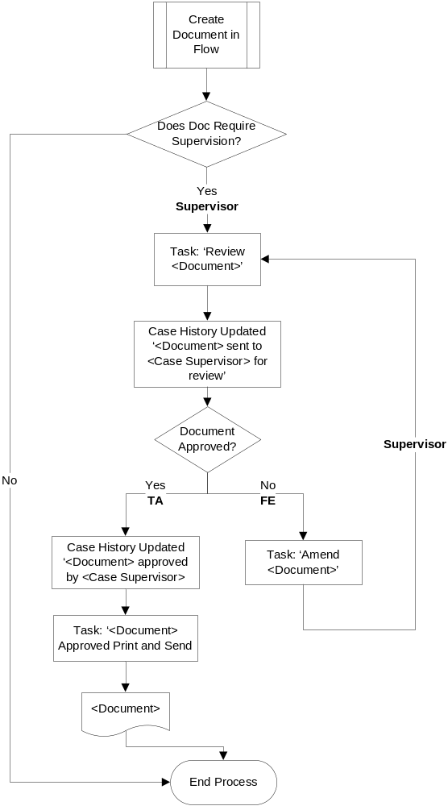

Creating Documents within a Flow
Upon submission of a task which produces a document:
If the Document does not require supervision
Then
[END] (the user should Immediately be presented with the document and the process ends).
If the Document Requires supervision
Then a task should be assigned to the supervisor on the case Task: Review <Document>
Then system writes the Case History line
<Document> sent to <Case Supervisor> for review
Upon the Case Supervisor selecting the Pending Task Review <Document> the form Task: Review <Document> is immediately presented to the Case Supervisor for them to Approve a document.
If
Approve Document? = No
Then system Immediately schedules a pending task to the Lawyer on the case Task: Amend <Document>
Upon the Lawyer selecting the Pending Task Task: Amend <Document> the form Task: Amend <Document> is immediately presented to the Case Lawyer to view why the payment has been rejected by the Case Supervisor
When the user selects save the system Immediately schedules a pending task back to the Supervisor on the case Task: Review <Document>
If
Approve Document? = Yes
Then Upon submission of the form:-
Then system writes the Case History line
<Document> approved by <Case Supervisor>
The system Immediately schedules a pending task to the Team Administrator on the case Task: <Document> Approved Print and Send
Upon the Team Administrator selecting the Pending Task Task: <Document> Approved Print and Send the document is presented to the user.
[END]

4.2 Creating Documents Ad hoc.

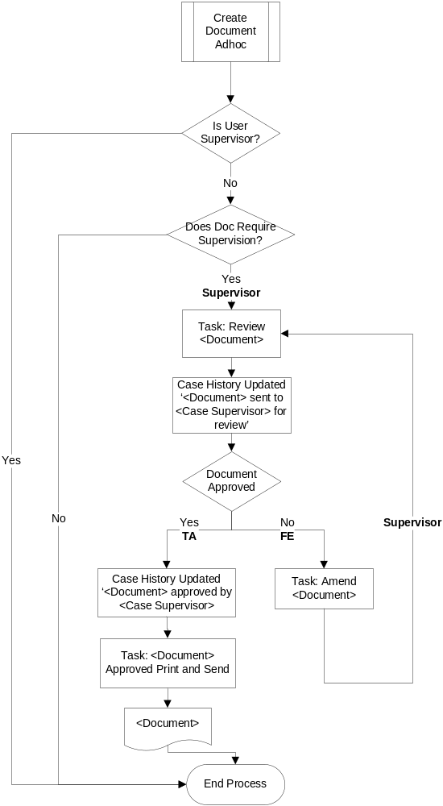

Creating Documents Ad hoc
Upon submission of a task which produces a document:
If the user is a Supervisor
Then
[END] (the user should Immediately be presented with the document and the process ends).
If the user is not a Supervisor
And
If the Document does not Require supervision
Then
[END] (the user should Immediately be presented with the document and the process ends).
If the user is not a Supervisor
And
If the Document Requires supervision
Then a task should be assigned to the supervisor on the case Task: Review <Document>
Then system writes the Case History line
<Document> sent to <Case Supervisor> for review
Upon the Case Supervisor selecting the Pending Task Review <Document> the form Task: Review Document is immediately presented to the Case Supervisor for them to Approve a document.
If
Approve Document? = No
Then system Immediately schedules a pending task to the Lawyer on the case Task: Amend <Document>
Upon the Lawyer selecting the Pending Task Task: Amend <Document> the form Task: Amend <Document> is immediately presented to the Case Lawyer to view why the payment has been rejected by the Case Supervisor
When the user selects save the system Immediately schedules a pending task back to the Supervisor on the case Task: Review <Document>
If
Approve Document? = Yes
Upon submission of the form:-
Them the system writes the Case History line
<Document Name> approved by <Case Supervisor>
The system Immediately schedules a pending task to the Team Administrator on the case Task: <Document> Approved Print and Send
Upon the Team Administrator selecting the Pending Task Task: <Document > Approved Print and Send the document is presented to the user.
[END]

4.4. Reminder Task List

Throughout a case, the following Tasks will need to be scheduled with reminder tasks within the stated days (‘Time/Date Scheduled’ column below) and produce the listed documents.

The Supervision level process itself is generic to all clients, however some of the Documents produced and the time/date scheduling for tasks that are listed below are Client specific. The Client Specific documents will be segregated for individual matters within the document filtering section of FloCase.

The table and diagrams below refers specifically to Zurich and should not impact on existing healthcare matters or preceding matters for other Clients as their requirements will be different.

Report/ Task/ Activity | Created By on system | Supervised By/ Task Assigned to | Priority in Task List (High, Low, Normal) | Time/Date Scheduled | Documents
1) Initial Client Report | Level 2: Lawyer | Level 1: Case Supervisor | High | Reminder task: To appear at 3 days (send within 14 days). | Non delegated initial report of Case Management Strategy
2) Action Plan (File Review- if delegated) | Level 2: Lawyer | Level 1: Supervisor (to review file with Level 2: Lawyer) | Normal | Reminder Task: To appear at 28 days from Initial Client Report Reminder | Zurich - Action Plan
3) Subsequent Client Reports (to be sent to client every 3 months or option to send earlier if any material change) | Level 2: Lawyer | Level 1: Case Supervisor | High | Schedule every 2 months as will allow lawyer time to complete (with ability to run earlier if necessary) | Non Delegated Case Advise/ Update Report
4) Part 36 Offers Client Report | Level 2: Lawyer | Level 1: Case Supervisor | High | From saving a Part 36 Offer | Non Delegated Case Advise/ Update Report
5) Trial Review |  | Level 1: Case Supervisor  (do Trial review with Level 2: Lawyer) | High | From entering a hearing date | Pre-trial review checklist
6) Trial Report | Level 2: Lawyer | Level 1: Case Supervisor | High | Remind at 12 weeks when do review to allow lawyer time to draft. To be filed no later than 6 weeks prior to trial or first date of trial window. | 1) Trial or ADR Standard Case Status Report  2) Letter to Zurich, insured, broker, (witness name) informing of trial date
7) Outcome Reports | Level 2: Lawyer | Level 1: Case Supervisor | High | -After Trial or ADR (Alternative Dispute Resolution) - same day call client  -Within 2 working days of trial. | Outcome Report
8) Settlement Report (if settles without Trial) | Level 2: Lawyer | Level 1: Case Supervisor | High | When Save selected on Settlement | Outcome Report
9) Payment Request  All Offshore and Non Offshore Payment | Level 2: Lawyer | Level 1: Case Supervisor | High | Dealt with in Payments Scope | Zurich Offshore Payment Request Form  (Dealt with in Payments Scope)

The criteria which specifies a case as being Zurich only is as follows:

Client Groups (Case table Case_MatterGroup):
- Z-KKC
- Z-UNS
- ZUR

Client Code (Case table Case_ClientCode):
- 130936

These values are also held against the Client in Aderant with the values in Case populated at matter inception.

Explanation of when each stage occurs:

The above table is divided into four flows as described below:

4.4.1 Flow 1: At Matter Inception (Zurich Cases Only)

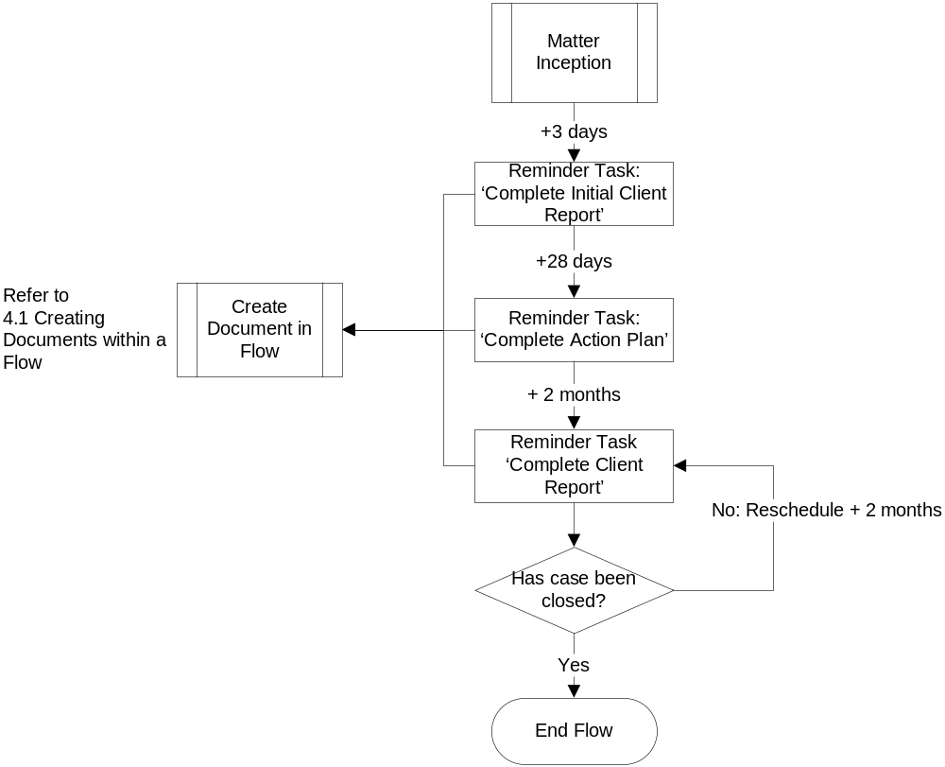
- When a matter is incepted, a task needs to be scheduled to complete an Initial Client Report (acknowledge instructions, nature and basis of instructions, conflict of interest and appropriate deadlines for acknowledgment of service/defence, also identifying issues requiring urgent attention).
This needs to be scheduled at day 3 for the Lawyer on the case (the Lawyer has to send within 14 days). When the document is created the above described Flows take place (supervisor approval).

- 28 Days from the Initial Case Report Reminder, a task needs to be scheduled to do an Action Plan (this is a full file review to identify further steps to be taken to progress).

- After the Action Plan, subsequent Client Reports need to be scheduled every 2 months (with the ability to run earlier).

4.4.2 Flow 2: When a Part 36 Offer has been created

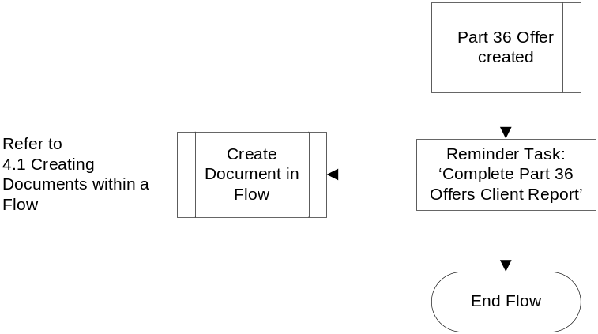

- During a case when a Part 36 offer has been made/received, a Complete Part 36 Offers Client Report needs to be scheduled immediately for the Lawyer on the case.

4.4.3 Flow 3: Trial Stage

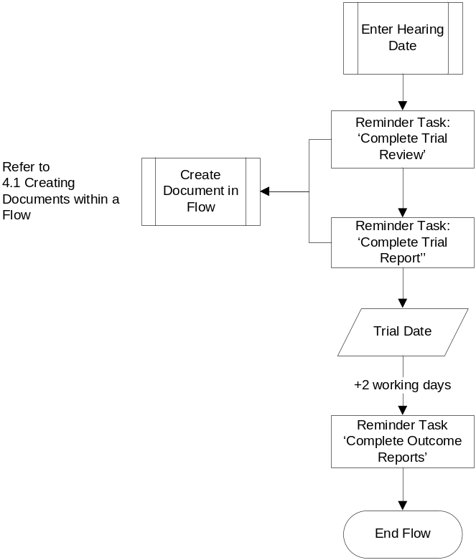

- When a hearing date is entered on a case, a task needs to be immediately scheduled to Complete Trial Review for the Lawyer on the case.

- When the Trail review reminder appears, the system should also immediately schedule a Complete Trial Report reminder task for the Lawyer on the case.

- Within 2 working days of the Trial date a reminder task needs to be scheduled Complete Outcome Reports for the Lawyer on the case. The report needs to be done after the Trial or ADR.

4.4.4 Flow 4: Settlement of a case

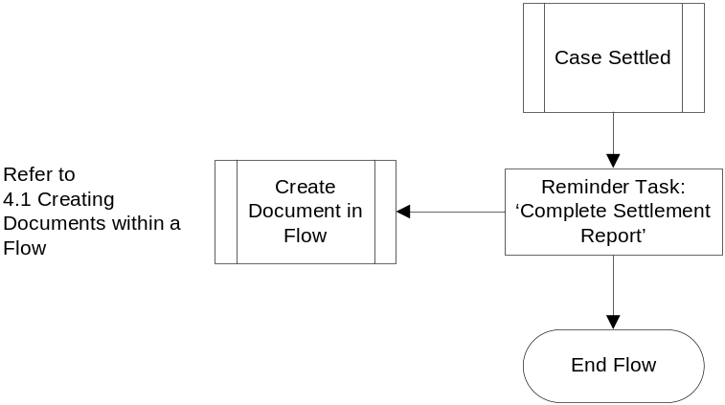

- When the case has been settled, a reminder task needs to be scheduled immediately to Complete Settlement Report for the Lawyer on the case.

- Payment forms are created immediately on settlement but are available ad hoc. They still need to run through the supervisor approval process.

Navigation

Where will the Flow be launched from

Task: Review Document: From Pending Tasks screen.
Task: Amend Document: From Pending Tasks screen.
Task: Complete Initial Client Report: From Matter Inception, on the Pending Task Screen.
Task: Complete Action Plan: 28 days from the Initial Client Report, on the Pending Task screen.
Task: Complete Client Report: 2 months after the Complete Action Plan task, on the Pending Task screen.
Task: Complete P36 Offers Client Report: After a Part 36 offer has been created, on the Pending Task screen
Task: Complete Trial Review: After a Hearing date is entered, on the Pending Task screen.
Task: Complete Trial Report: After a Hearing date is entered, on the Pending Task screen.
Task: Complete Outcome Reports: 2 days after the Trial Date, on the Pending Task screen.
Task: Complete Settlement Report: When a case is settled, on the Pending Task screen.

Where should the Flow return to
All of the above listed tasks once dealt with should navigate the user back to the Pending Task screen.

SQL Tables

Table

Amendment to dmsTemplates add dmsTemplates_ReqSup of data type bit defaulted to 0

Amendment to AppTask add AppTask_DateModified of data type smalldatetime defaulted to today’s date

Amendment to AppTaskDocumentVersion add the following
- AppTaskDocumentVersion_ Approved of data type nvarchar(255).
- AppTaskDocumentVersion_ReviewComments of data type nvarchar(max).

Lookup
N/A

Field

- Name: This column will contain the (label name) of the field
- Field Type: This column should contain the type of the form field i.e. Textbox, Drop Down List, etc.
- Mandatory: If the field is mandatory or not.
- Rule: Any Special rule for the field – i.e. should the field only be visible in certain circumstances
- Form: FloCase Form where field is located (if applicable).
- Description: A short description of what the field is for.

Name | Field Type | Mandatory | Rule | Form | Description
Requires Supervision | Checkbox | n/a | n/a | Document Management-Template Maintenance screen. | Check when document is created if requires supervision flow
Last Modified Date | Date/time | n/a | Hidden | Reminder/Schedule a task
Date Assigned | Date/time | n/a | Read Only | - Outlook Landing Page- Pending Tasks  - Outlook Landing Page- Team Pending Tasks  - Pending Tasks Tab (matter level) | Links to Last Modified Date on Reminder/Schedule a task screen
All New form fields in ‘Amend Documents’ and ‘Review Documents’ as described previously in scope.

Stored Procedures

Fetch
Amendments required to the following stored procedures to accommodate the new fields:
- dmsTemplates_Fetch – New field dmsTemplates_ReqSup residing in dmsTemplates should be added to the return values
- AppTaskConsole_Fetch – New field AppTask_DateModified residing in AppTask should be added to the return values
- AppTask_Fetch – New field AppTask_DateModified residing in AppTask should be added to the return values
- AppTaskConsole_Fetch New field AppTask_DateModified residing in AppTask should be added to the return values.
- AppTaskDocumentVersion_Fetch – New fields AppTaskDocumentVersion_ReviewComments and AppTaskDocumentVersion_ Approved residing in AppTaskDocumentVersion should be added to the return values

Save
Amendments required to the following stored procedures to accommodate the new fields:
- dmsTemplates_Save – New field dmsTemplates_ReqSup residing in dmsTemplates should be added to both the inputs and the save mechanism within the stored procedure
- AppTask_CreatePending – New field AppTask_DateModified residing in AppTask should be added to the save mechanism within the stored procedure defaulted to the date and time of execution (i.e. GETDATE())
- Apptask Reschedule – New field AppTask_DateModified residing in AppTask should be added to the save mechanism within the stored procedure defaulted to the date and time of execution (i.e. GETDATE())
- AppTaskDocument_IncVersion – New fields AppTaskDocumentVersion_ReviewComments and AppTaskDocumentVersion_ Approved residing in AppTaskDocumentVersion should be added to the save mechanism within the stored procedure. AppTaskDocumentVersion_ Approved should be defaulted to No if the document requires supervision and no value has been passed for this field

Document Templates

Please list below details of any document required as part of this scope.
Status:  New / Existing / Replacement  (please state) | Received Document Name (from business) | Document File Name  (ie Document.dot) | Document Description  (as viewed on FloCase) | Template Description Code  (Code for auto description) | Template Group:  BLM/ Documents/ Court Doc/ Letters/ Other  (Please State) | Availability? (Flow Only, Ad hoc or Both)
New | Non delegated initial report of Case Management Strategy | Client_Report_CMSNonDel_ZUR.dot | Case Management Strategy Report (Non Delegated) | Rep. NonDel CMS | BLM | Both
New | Zurich - Action Plan | BLM_ActionPlan_ZUR.dot | Action Plan | Act. Pln | Documents | Both
New | Non Delegated Case Advise/ Update Report | Client_Report_AdviceUpdateNonDel.dot | Case Advice Update Report (Non Delegated) | Rep. NonDel AdvUpdate | Documents | Both
New | Pre-Trial Review Checklist | BLM_Checklist_PreTrial.dot | PreTrial Check | BLM_Checklist_PreTrial.dot | Documents | Both
New | Trial or ADR Standard Case Status Report | Client_Report_CaseStatusNonDel.dot | Letter to Client providing Trial/ADR Status Report | Ltr. Cl Trial/ADR rep. | Documents | Both
New | Letter to Zurich, insured, broker, (witness name) informing of trial date | Party_Letter_TrialDate.dot | Letter to Party informing of Trial Date | Ltr. TrialDate | Letter | Flow Only
New | Outcome Report | Client_Report_Outcome | Outcome Report | Rep. Outcome | Documents | Both
Existing | Zurich Offshore Payment Request Form | Payment_Request_Zurich.dot | Payment Request Form | Pay. Req. | Documents | Ad Hoc

/tmp/lo/0000.doc

